**Computer Networks Lab 5**

**Name: Vaibhav Chaudhari**

**ID: 2017B5A70834G**

**The server will accept its port number as the input parameter. (5 marks)**

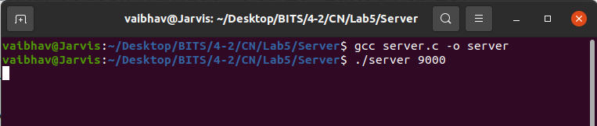

We can see that the port number is taken as the input parameter here.

**The client sends a query to server requesting data from <filename> to the server. The client will accept server's IP address, server' port number, and the requested <filename> as input parameters. (5 marks)**

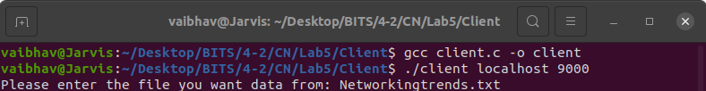

Here we can see that the port number and the IP address is taken as the Command Line argument and the filename is taken as the input from STDIN.

**Output: The server parses the query and returns the first 10 bytes of the file <filename>. (5 marks)**

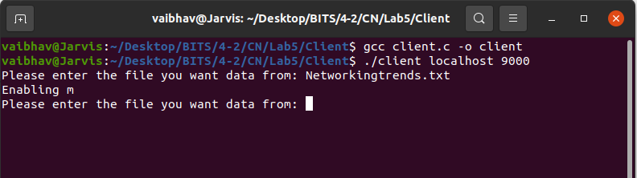

Here we can see that the server parses the query and return the first 10 bytes of the input file.

**On receiving the data, the client creates the file <filename> and stores the data. (5 marks).**

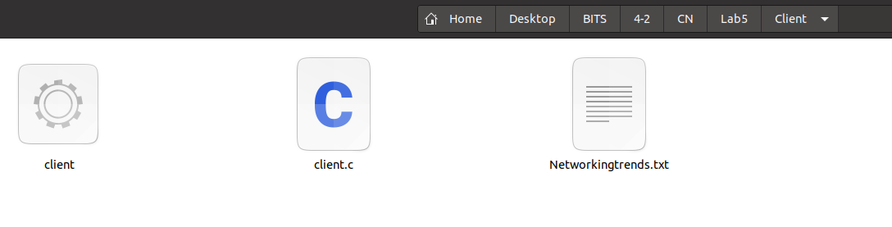

We can see that the file with the input name is created in the client directory.

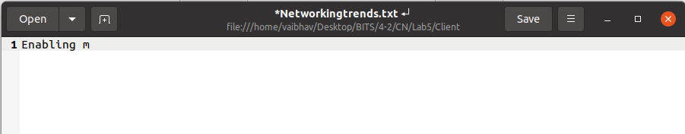

We can see that the first 10 bytes of the file are stored in the new file created in the client directory.

**If the requested <filename> file is missing, the server sends an empty file to the client. (2 marks)**

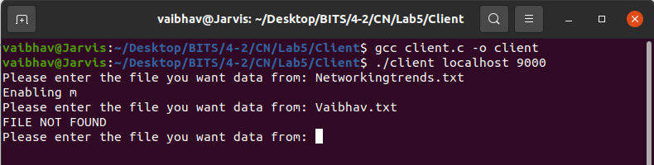

We can see that the Vaibhav.txt does not exist in the server directory. I have output “FILE NOT FOUND” and have also created an empty file with the same name in the client directory.

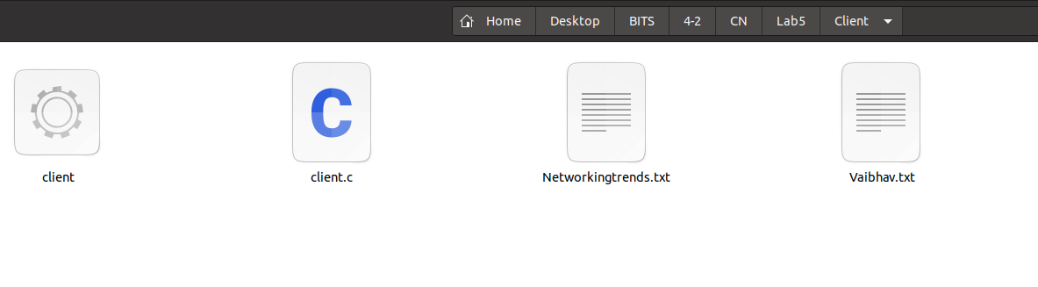

Here we can see that the empty file is created in the client directory.

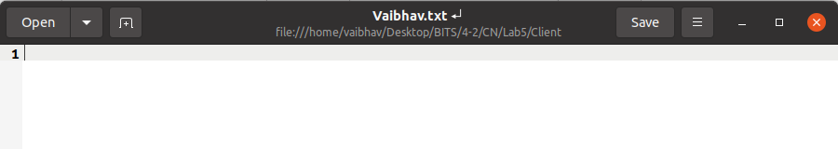

We can see that the file is empty.

**If the server is unreachable, the client must say so. (2 marks)**



As we can see that if the port number does not match, we get an error.



We can see that the server is not running yet so the connection is refused and ERROR message is displayed.